## PROGRAM DEFINITION

|  |
| --- |
|  |
| * Program untuk inquiry data unit |

## RELATED TABLES

|  |  |
| --- | --- |
|  | **Access** |
| * PMM_REMINDER | * R |

## ROLES

|  |  |
| --- | --- |
|  | **Test** |
| * User yg mempunyai akses ke program |  |

## INITIAL PROCESS

|  |  |
| --- | --- |
|  | **Test** |
| * Set VAR_COMPANY_ID = Login User’s Company ID * Set VAR_USER_ID = Login User ID * Set VAR_LANGUAGE_ID = Login User’s Language ID * Get Property List to Combobox Property [PROPERTY_LIST]:   EXEC RSP_GS_GET_PROPERTY_LIST VAR_COMPANY_ID, VAR_USER_ID  Set Value : CPROPERTY_ID Set Display : CPROPERTY_NAME  As Parameter: CPROPERTY_ID |  |

## UNIT LIST

### USER INTERFACE

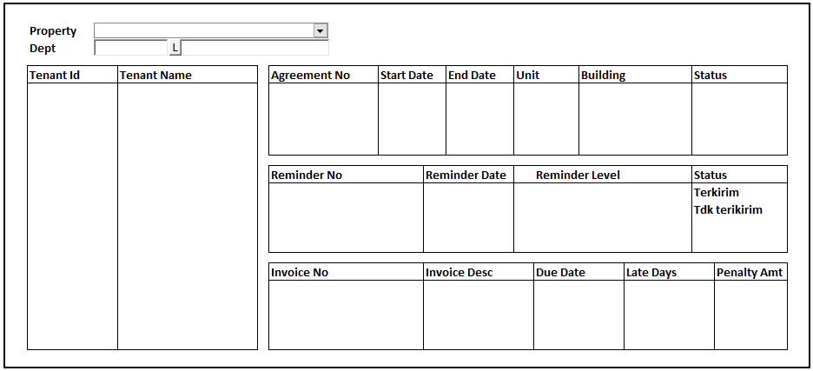BUTTON DEFINITION

|  |  |
| --- | --- |
| **Button Name** | **Action** |
|  |  |
|  |  |

### INITIAL PROCESS

|  |  |
| --- | --- |
|  | **Test** |
|  | S |

### DISPLAY PROCESS

#### HEADER FIELD DEFINITION

|  |  |  |  |
| --- | --- | --- | --- |
| **Name** | **Field** | **Type** | **Validation** |
| Property | Value: CPROPERTY_ID Display: CPROPERTY_NAME | Combobox | * Always Enabled * IF Selected Value Changed THEN   + Reset Dept Lookup   + Reset All Grid |
| Dept | * CDEPT_CODE * CDEPT_NAME * Value : CDEPT_CODE | Textbox & Button Lookup | * Department Name always disabled * Dept Code & button lookup always enabled * Do Lookup GSL00710 DEPARTMENT PROPERTY LOOKUP, Parameter:   + VAR_COMPANY_ID   + Selected Property ID (CPROPERTY_ID)   + VAR_USER_ID * Set CDEPT_CODE = lookup.CDEPT_CODE * Set CDEPT_NAME = lookup.CDEPT_NAME * IF CDEPT_CODE <> ‘’ THEN * Do REFRESH PROCESS |
|  |  |  |  |

#### FIELD DEFINITION GRID HEADER (LEFT)

|  |  |  |  |
| --- | --- | --- | --- |
| **Name** | **Field** | **Type** | **Validation** |
| Tenant ID | CTENANT_ID | Textbox |  |
| Tenant Name | CTENANT_NAME | Textbox |  |

#### FIELD DEFINITION GRID DETAIL AGREEMENT (TOP)

|  |  |  |  |
| --- | --- | --- | --- |
| **Name** | **Field** | **Type** | **Validation** |
| Agreement No | CAGREEMENT_NO | Textbox |  |
| Start Date | DSTART_DATE | Datetime |  |
| End Date | DEND_DATE | Datetime |  |
| Unit | CUNIT | Textbox |  |
| Building | CBUILDING | Textbox |  |
| Status | CAGREEMENT_STATUS | Textbox |  |

#### FIELD DEFINITION GRID DETAIL REMINDER (MIDDLE)

|  |  |  |  |
| --- | --- | --- | --- |
| **Name** | **Field** | **Type** | **Validation** |
| Reminder No | CREMINDER_NO | Textbox |  |
| Reminder Date | DREMINDER_DATE | Datetime |  |
| Reminder Level | CREMINDER_LEVEL | Textbox |  |
| Status | CSTATUS | Textbox |  |

#### FIELD DEFINITION GRID DETAIL INVOICE (BOTTOM)

|  |  |  |  |
| --- | --- | --- | --- |
| **Name** | **Field** | **Type** | **Validation** |
| Invoice No | CINVOICE_NO | Textbox |  |
| Invoice Desc | CINVOICE_DESC | Textbox |  |
| Due Date | DDUE_DATE | Datetime |  |
| Late Days | ILATE_DAYS | Decimal | Decimal places 0 |
| Penalty Amt | NPENALTY_AMOUNT | Decimal | Decimal places 2 |

#### VALIDATION

|  |  |  |
| --- | --- | --- |
| **Field** | **Condition** | **Validation Message** |
|  |  |  |
|  |  |  |

## REFRESH PROCESS

#### ACTION

|  |
| --- |
|  |
| * Refresh Grid Header dengan RSP_PM_GET_REMINDER_INQUIRY_HD dengan parameter   + VAR_COMPANY_ID   + Selected Property (CPROPERTY_ID)   + Selected Department (CDEPT_CODE)   + VAR_LANGUAGE_ID * IF Grid Header isnot Nothing THEN   + Refresh Grid Detail Agreement (TOP) dengan RSP_PM_GET_REMINDER_INQUIRY_DT_AGR dengan parameter     - VAR_COMPANY_ID     - Selected Property (CPROPERTY_ID)     - Selected Department (CDEPT_CODE)     - Selected Tenant Id From Grid Header     - VAR_LANGUAGE_ID   + IF Grid Detail Agreement isnot Nothing THEN     - Refresh Grid Detail Reminder (MIDDLE) dengan RSP_PM_GET_REMINDER_INQUIRY_DT_REM dengan parameter       * VAR_COMPANY_ID       * Selected Property (CPROPERTY_ID)       * Selected Department (CDEPT_CODE)       * Selected Tenant Id From Grid Header       * Selected Agreement No From Grid Detail Agreement (TOP)       * VAR_LANGUAGE_ID     - IF Grid Detail Reminder isnot Nothing THEN       * Refresh Grid Detail Invoice (BOTTOM) dengan RSP_PM_GET_REMINDER_INQUIRY_DT_INV dengan parameter         + VAR_COMPANY_ID         + Selected Property (CPROPERTY_ID)         + Selected Department (CDEPT_CODE)         + Selected Tenant Id From Grid Header         + Selected Agreement No From Grid Detail Agreement (TOP)         + Selected Reminder No From Grid Detail Reminder (MIDDLE)         + VAR_LANGUAGE_ID     - ELSE (Grid Detail Reminder is Nothing)       * Reset Grid Detail Invoice (BOTTOM)   + ELSE (Grid Detail Agreement is Nothing)     - Reset Grid Detail Reminder (MIDDLE) * ELSE (Grid Header is Nothing)   + Reset Grid Detail Agreement (TOP) |
|  |

# CR LIST

|  |  |  |
| --- | --- | --- |
| **CR** | **Description** | **Notes** |
|  |  |  |
|  |  |  |
|  |  |  |
|  |  |  |

#### TEMPLATE

#### VALIDATION

|  |  |  |
| --- | --- | --- |
| **Field** | **Condition** | **Validation Message** |
|  |  |  |
|  |  |  |

#### ACTION

|  |
| --- |
|  |
|  |